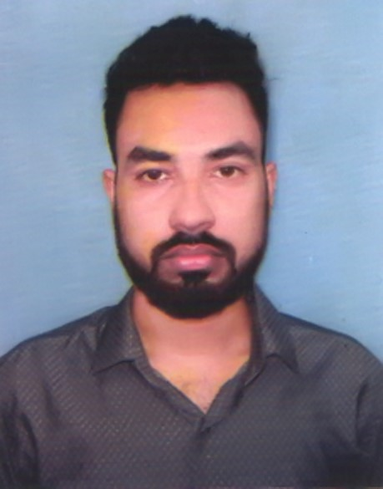
RESUME OF
MD. ASHIQUR RAHMAN
Mailing Address:
Email: contact.ashiq04@gmail.com
Cell: +8801722445525

OBJECTIVE

To get an opportunity for this job to enrich the department by my positive efforts and in an organization that offers a highly structured working environment.

PROFESSIONAL INVOLVEMENT

Organization | Department | Service Length | Working Area
Square Toiletries Limited | Human Resource Department | 1 year 6 Month. | - Recruitment & Selection  - Training & Development  - Maintain Compliance & Regulatory Issues
RUNNER GROUP | Human Resource Division | 04 Months Internship | - Recruitment & Selection  - Employee Relation

ACADEMIC BACK GROUND

Bachelor of Business Administration (BBA)
Name Of Institute : Varendra University,Rajshahi.
Major : Human Resource Management.
Year Of Passing : 2018
CGPA : 3.42 (Out of 4.00)

Higher Secondary Certificate (H.S.C)
Name Of Institute : Rajshahi College,Rajshahi.
Group : Business Administration.
Board : Rajshahi.
Year Of Passing : 2012
Result : 4.10 (Out Of 5.00)

Secondary School Certificate (S.S.C)
Name Of Institute : Cantonment Public School & College, Sayedpur, Nilphamari.
Group : Business Administration.
Board : Dinajpur.
Year Of Passing : 2010
Result : 4.19 (Out Of 5.00)

COMPUTER SKILLS

Name of Courses
- BPM, F&A under LICT program from Bangladesh ICT division.
- M.S Office Package (Word/ Excel/ Access/ Power Point/ Advence Excel)

LANGUAGE PROFICIENCY

A good communication skill in Bengali and English.

Speaking Reading Writing

English Good Excellent Excellent
Bengali Excellent Excellent Excellent

PERSONAL INFORMATION

Name : Md. Ashiqur Rahman
Father's Name : Md. Shadeq Ur Rahman
Mother's Name : Parvin Rahman
Permanent Address : Village: Koyalipara
P.S: Bagatipara, Dist: Natore.
Home District : Natore
Date Of Birth : 04/10/1995
Religion : Islam
Nationality : Bangladeshi (By Birth)
Marital Status : Unmarried

Reference

Name: Shahriar Jan Quadri  Designation: Manager (HR Division)  Organization: Runner Group of Industries  Contact Number: 01730405060  Email: shariar@runnerbd.com | Name: Kaniz Habiba Afrin  Designation: Asst. Professior  Organization: Varendra University  Contact Number: 01736329418  Email: kanizafrin@yahoo.com

DECLARATION

I hereby declare that to the best of knowledge and belief, these data correctly described my qualifications and me; I understand that any misstatement described here in my lead to my disqualification or dismissal if I get this opportunity.

Md. Ashiqur Rahman

